Janitor User Guide
S. Hamblett

Table of Contents
1.Introduction 3
2.Installation 4
3.Welcome 5
4.Database 6
5.Backup 7
6.FTP 10
7.Search 12
8.Logs 13
9.Upgrade 14
10.Events 15
11.Link Check 16
12.Workflows 17
Site Backup 17
13.Under the Hood 18
14.Security 19
15. Further development 20

Introduction
The Janitor component is intended to allow a site maintainer to perform site maintenance functions without using a plethora of external tools. Janitor aims to concentrate most site maintenance tasks into in central component.
Janitor uses a mixture of mature 3rd party components such as SQLBuddy and special to type functions specific to Revolution installs to ease site maintenance tasks.
The usage of 3rd party applications greatly reduces the complexity of this component, the code production being more of an integration task than an implementation task. This maximises the usage of already written, tested, used and understood applications and minimises the amount of code needed to be written, which in general is a good thing.
Although these applications are general purpose in nature they are augmented with Revolution specific functions to tailor the component as much as possible for Revolution usage.
For a further explanation of how this package is put together see section 13
For security considerations see section 14
For further development information see section 15

Installation
The Janitor package is installed as any other, download the package using package manager and install, or download the transport file into your packages directory and perform a local package installation. Any set up that needs to be performed such as the setting of file permissions are done during installation so the user has nothing to do here over and above a normal install.
The component has 9 tabs, namely Welcome, Database, Backup, FTP, Search, Logs , Upgrade, Events and Link Check.

Welcome
The Welcome tab is a simple welcome screen explaining the purpose of Janitor and quickly describing what the tabs are for, this tab contains no functionality.

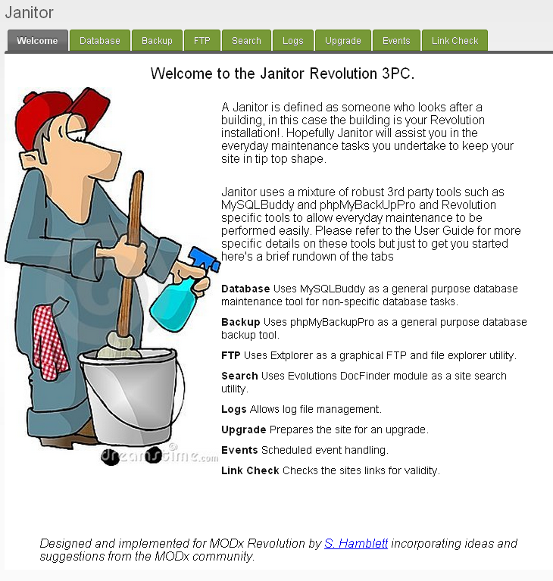

Database
The Database tab utilises the SQLBuddy web based MYSQL database administration tool. On entering the tab you are presented with a login screen, entering your MYSQL details allows access to the application.

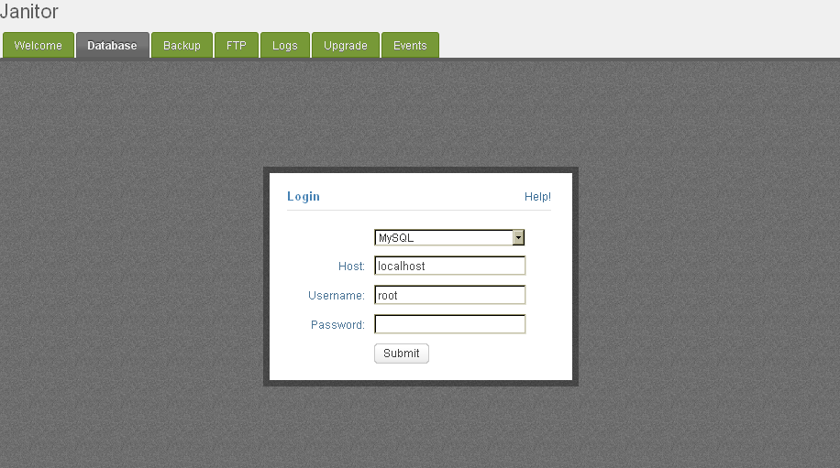
The decision to not tie this application to the database specified in your Revolution installation is a conscious one. Often the user of this database does not have sufficient privileges to perform full administration duties, so Janitor allows the user to specify any credentials he thinks appropriate for the task at hand. This also adds an additional level of security but this is not relied on, see the Security section later.
The application is a full implementation of SQLBuddy, please refer here for fuller documentation on its features etc.

Backup
The Backup tab utilises the phpMyBackupPro MYSQL backup application to allow database backups to be performed.
On first entry to the tab the following screen is displayed :-

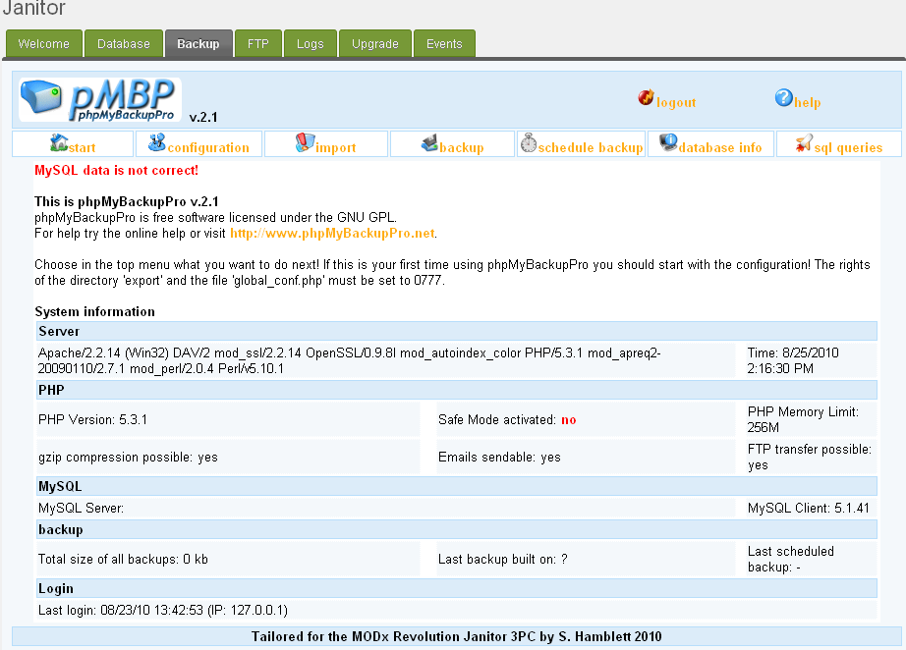

No MYSQL credentials or other information has yet been set. Select the 'Configuration' menu option to get the following display :-

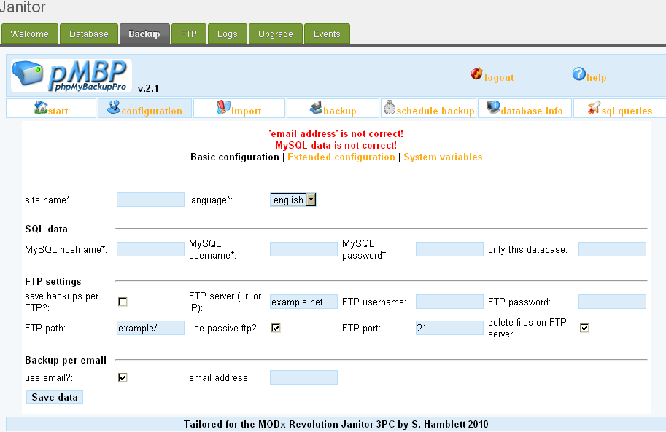
Please enter your MYSQL credentials and other information as appropriate and press the 'Save Data' button. Now press the 'logout' button at the top of the page. This returns you to the applications login screen which from now on you will be presented with when you re-enter this tab.

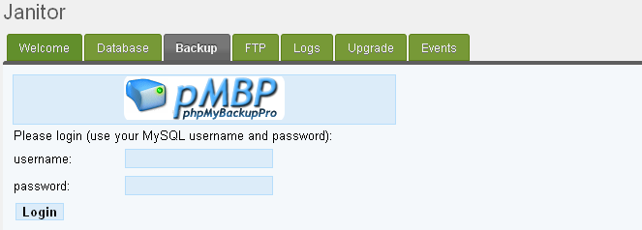

In the same manner as SQLBuddy above you are not tied to any particular MYSQL credentials. The application is a full implementation of the phpMyBackupPro web based backup utility, for further documentation please refer here
Note: the scheduled backup facility can be used if you follow the instructions in the phpMyBackupPro documentation, it is not however automatically set up and it is not yet integrated with the Events tab.

FTP
The FTP tab utilises the eXtplorer web based graphical FTP and file explorer utility. This is a lightweight Extjs based application ideally suited for integration into installations such a Revolution.
On entry to the tab the following screen is displayed :-

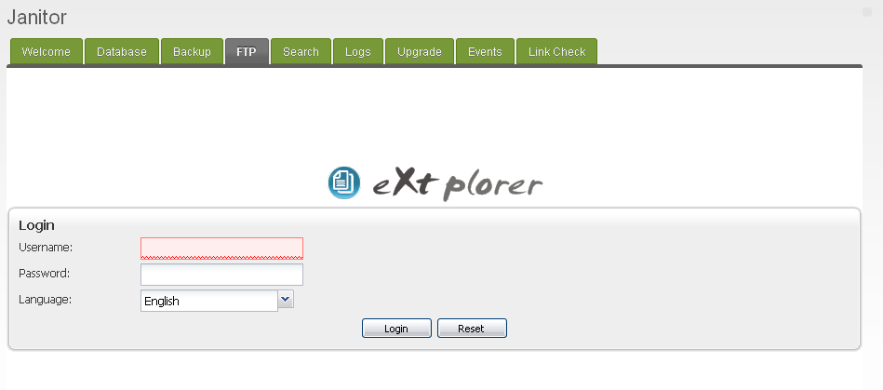
Initially the credentials are admin/admin. On first login you are prompted to change your password. The utility allows the creation of other users with specific rights of access should you need to do this.
The login screen has been left deliberately in place to allow a more fine grained control of access to this facility. Some manager users for instance may not be allowed to use this although they will be granted access to Janitor itself.
After doing this you are presented with the following display :-
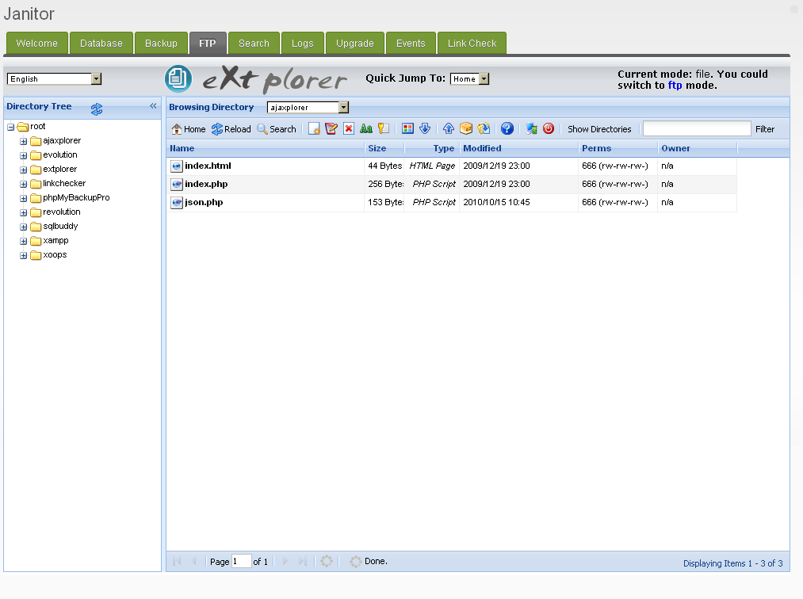
The eXtplorer utility has two modes of operation, as a file browser and as an FTP client. These can be switched back and forth using the Current Mode: selector in the top right hand corner of the screen. The file browser has a file preview ability and also the ability to archive files using zip.
Fuller details of this tool can be found here
Note that the application utilises the browser download facility to download files, so any downloads you make will be deposited in the download directory as set in your browser, not in your Revolution installation.

Search
The Search tab provides a general site search/replace facility. On entry to the tab the following page is displayed :-

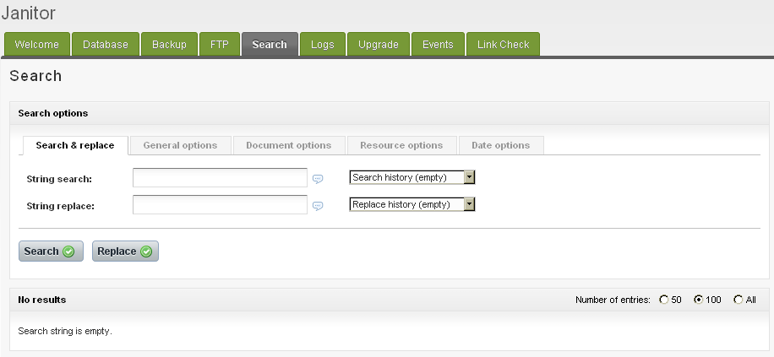
This function is a direct re-implementation in Revolution of the Evolution DocFinder module, full details of this module including documentation and demo sites can be found here however the tool itself is intuitive to use and uses AJAX communication giving a nice look and feel.

Logs
The Logs tab provides log management facilities specific to Revolution installations. On entry to the tab the following page is displayed. :-

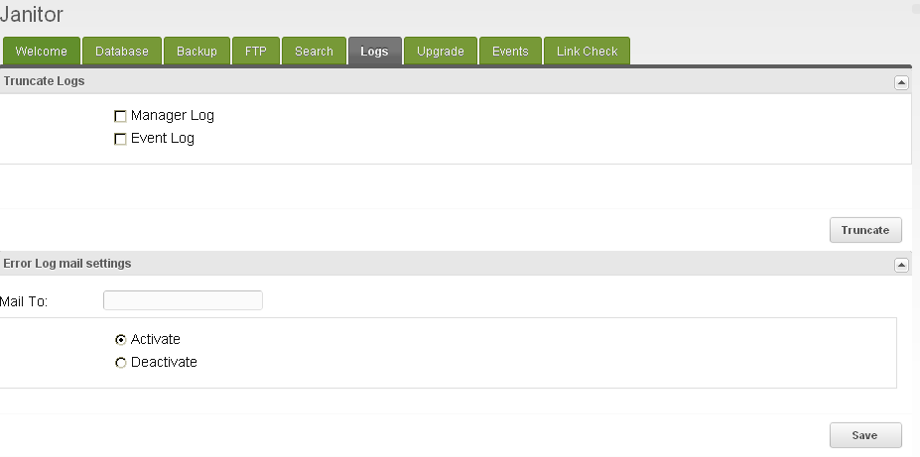
As can be seen the tab consists of two panels, the first one named 'TRUNCATE LOGS' allows both the manager and event logs to be truncated quickly.
The second panel named 'ERROR MAIL LOG SETTINGS' is a support tab for the error mail function. This function will periodically scan the Revolution log for errors and if found will automatically mail an alert to the account specified. The function can be activated and deactivated from here. If no account is specified the system setting for administrators mail is used.
In this release the panel saves and restores the settings only, the actual error log scanning functionality will be provided as part of the Event tab functionality which is not present in this release.

Upgrade
The Upgrade tab allows the user to prepare the installation for an upgrade. On entry to the tab the following screen is displayed :-

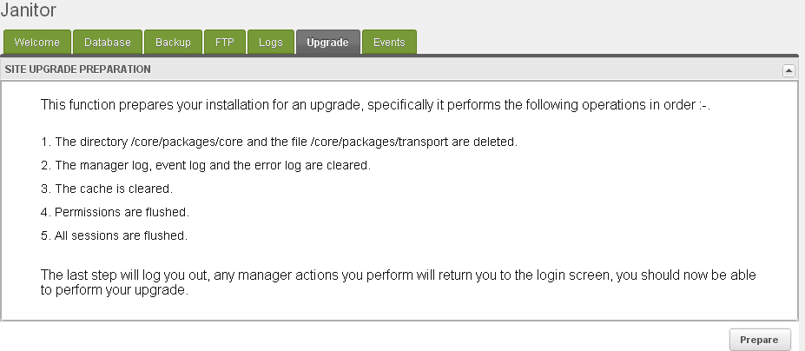
As can be seen from the above picture the steps outlined are performed in the order specified to prepare the installation for an upgrade. It should be noted that this function will always return a successful outcome. Some steps like step 1 for instance are not crucial, if this fails then this will be corrected in the setup function during upgrade, some steps can't really fail e.g. step 3 for instance.
On completion of this function please log out of the manager and perform the upgrade, you should find that execution of the last step forces this, i.e. if you try and invoke a manager function after this you should end up at the login screen.

Events
The Events tab allows the setting and maintenance of periodic tasks needed to maintain the site, an example of this is the error mail log function. User definable tasks are also available on this tab.
This tab is not implemented in this release and is still under development.
The user will be able to specify the name of either a snippet or a chunk to be fetched from the database and processed at a certain time on a one shot or recurring basis.
If a snippet is named the snippet is executed as a PHP script, this allows the full use of the MODx API or the inclusion of an external PHP script.
If a chunk is named the contents of the chunk will be treated as SQL and run as an SQL query in the current database connection.

Link Check
The Link Check tab performs a link correctness check of the site. On entry to the tab the following screen is displayed :-

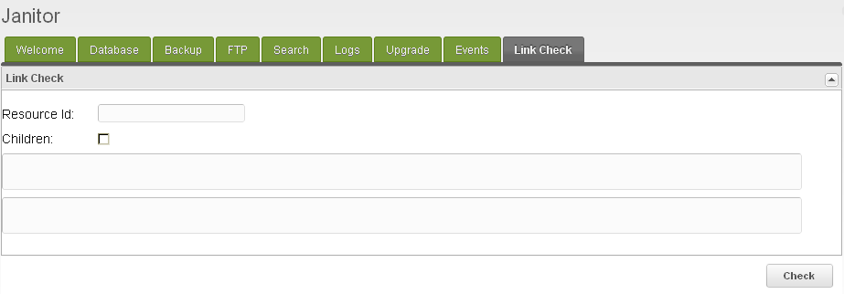
The link check can either perform a full scan of every published site resource if no resource is nominated or a check of a nominated published resource and optionally its children.
The page is split into two text windows, the top one supplying summary data of the check selected and the bottom one the full output of the scan.
The full log of the check can be found in the /assets/components/janitor/tmp directory stamped with the date and the time of the check. If this directory does not exist or is not writeable then a warning is given and the link check stops.
The check itself will look for broken/invalid links, redirects and valid links. The check is cumulative in that if say a link to resource 6 is verified on page 1 of the site it will not be checked for validity on other pages.
Depending on the size of the site this can take some time, there is a time out limit of 5 minutes allowed for this before the function returns. Currently this is not user changeable.
Note that if a check does time out the log file will show how the check progressed even though no information will be returned to the screen.
Resources can be dragged from the Resource tree view and dropped into the Resource Id box above. On landing they will be in the form [[~id]], the link checker will accept this notation for resources as well as an integer identifier.

Workflows
Although it is intended that the tools provided by Janitor are used as needed, on a standalone basis to provide the maximum possible flexibility it is possible to combine elements of functionality of these tools to provide a work flow based approach to administration tasks. This section documents some common administrative work flows and how they can be achieved using Janitor.

Site Backup
Site backup consists of making a backup of your MODx installation so that it can be moved to another server or in the case of disaster recovery re-installed. This comprises a backup of the database and the file system itself. To achieve this using Janitor we can use a combination of tools, in the following manner :-

- From the Backup tab login to your MYSQL server through the phpMyBackupPro login screen and select the 'backup' tab. Select the database you wish to backup along with any comments an further backup options.
- Press the 'Backup' button. A message will appear on the screen informing you of the name of the backup created. The backup file itself will be created in the directory assets\components\janitor\phpmybackuppro\xfig\export.
- Logout of the phpMyBackupPro utility and log in to eXtplorer on the FTP tab. By default you are presented with a file view rooted at your servers www/htdocs root directory. From here navigate to your installations top level directory and select 'archive' from the pull down menu. Follow the instructions and an archive of your site will be generated. This can then be FTP'd or transferred to another server for re-installation or storage.

At step 3 above you could of course move your previously generated database backup file before making a site backup, you could move it out of the site directory, make the site backup, place these two files together in a directory and then archive this, the eXtplorer tool gives you lots of ways to achieve this.
In step 1 you could create the database backup using the Database tab and the MYSQLBuddy utility, however this doesn't have as many options as phpMyBackupPro which you could also set up to do timed database backups e.g. overnight, should you need to.

Under the Hood
The component itself is just a collection of existing 3rd party web applications and custom code.
The 3rd party applications are simply 'iframed' into the relevant tab. This method allows the full functionality of the application to be preserved without writing mammoth amounts of code to fully integrate them.
They are however integrated to a certain extent, all the applications contain a security check hook, see the Security section below, also tailoring of page sizes, layout and other minor functional elements has been carried out so the applications themselves are no longer 'drop replaceable' with their upstream projects. This is deemed a small price to pay for the functionality gained.
This approach has been adopted to leverage the use of existing code where possible, this stops 'function creep' in areas such as database management.
Taking the Database tab as an example you could write your own custom code to do this of course using extjs/modext but there is absolutely no doubt that when you publish this some users will ask for 'can you make it do this', 'this would be good' etc.
As more and more functionality is added the application becomes more and more like SQLBuddy, so why not stop writing more and more code and simply integrate an already tried and tested database management application from the start!
Some code, the Link Checker for instance is 3rd party code that is used in the form of an external library and integrated into the main Janitor class itself.

Security
The usage of iframes gives both advantages and disadvantages. The main advantage is quick access to a fully functioning web based application, the main disadvantage is the security aspects of this.
An iframe is simply a web link so the application has to be 'web visible' from where you are linking it to. In Janitor the code for the 3rd party applications resides in the /assets/components/janitor path of your installation. This means that anybody can go to this :-
http://yourrevohost/assets/components/janitor/sqlbuddy
and the SQLBuddy login page will appear. Not good!! Although you still need login credentials to get to the database even presenting this screen is a security nightmare.
So, how do we prevent this? Basically the 3rd party application code has been modified so that the first thing it does is hook in a MODx specific security check.
This code first starts the session(any session start code in the original applications has been removed) then gets the session id. If you are a logged in manager user this should be the session as set by your Revolution installation and thus should be present in the sessions table in your database.
This check is then made, if a valid session* is found then the application is allowed to load, if not then you are accessing the application from an unauthorised source, e.g. a browser that is not logged into manager, CURL, wget etc. In this case a non-authorised page is returned.
Note:* currently the code just looks for a session id, not any more information, we may need to lock this down more as the component is developed.
IMPORTANT – This is a beta release, although I have tested this code as much as I can I have not exhaustively tested it from a security standpoint. I have not for instance gone into every PHP file of every application to check for correct behaviour, nor invoked all of them from a browser.

Further development
The component is fully functional in this release bar the Events tab. This is being worked on and will be developed further in future releases. More workflows will be added as people use the component. Also the security hook function will probably be beefed up over time.

